Pelada de Futebol

This is tool to control a small soccer league to play with friends (max 7 teams)

You need Python and QT4 installed to run the tool.

When running:

1. Define number of teams.

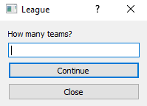

1. Define team names.

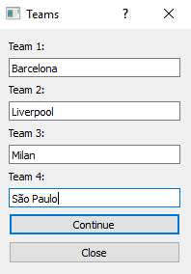

1. Add game results and see points and goals in bars.

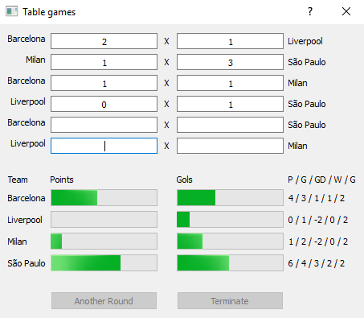

1. After all games are done you can terminate or select one more round of games.

